OBSETECH XU-Core

Small and reliable uncooled LWIR shutterless thermal imaging core with excellent vibration resistance designed for multiple integrations: UAVs, UGVs, weapon sights, handheld and other systems. XU-Core supports USB 2.0/3.0 raw data output.

Detector
Type | Uncooled FPA Microbolometer (Ulis)
Pixel resolution | 640×480
Pixel pitch | 17μm
Spectral Range | 8～14μm
NETD | ≤65mk@30℃
Image
Frame rate | 25Hz or 50Hz
Noise reduction | Digital filtering
Digital zoom | 2x, 4x, 8x / Smooth zoom
Polarity reversal | Available
Image flip | Horizontal, Vertical, 180° Flip
Startup | ≦3s
NUC | NBT shutterless technology, Digital calibration
Display
Video output | CVBS 50Hz（PAL）/ 60Hz（NTSC）
Palette | 12 palettes
Gain/Brightness adjustment | Auto / Manual
Interface
Serial port | 3.3V TTL
Analogue video | 1 port
Digital video | BT656
USB | Output RAW, YUV and command, support UVC/CDC
Power
Operating voltage | 5.0 - 12.0 VDC
Power consumption | ≦2.0 W
Environment
Operating temperature | -40℃～+65℃
Storage temperature | -50℃～+85℃
Humidity | 5-95% non-condensing
Axial shock level | Axial：100g/6ms，GJB 150-18
Lateral shock level | Lateral：40g/11ms，GJB 150-18
Vibration | GJB 150-16 2.3.1
Physical Characteristic
Dimension | 32mm x 32mm x 41mm (W x H x L)（without lens）
Weight | ＜65g（without lens）

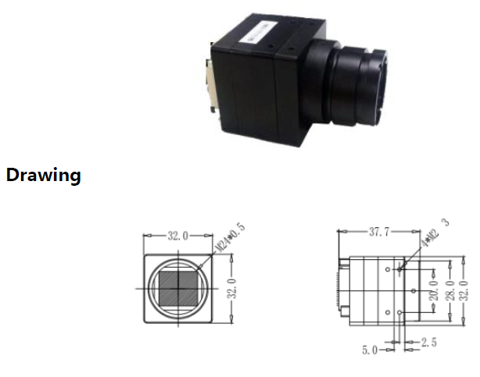

Pin Definition

