MODEL AR-50

APPLIcation Note

SATCOM RECEIVER PERFORMANCE

The AR Modular RF Model AR-50 Booster Amplifier provides superior up and downlink performance for enhancing UHF Satellite communications. Properly setting up the Receive path will maximize the link quality and reliability.

The AR-50 automatically detects and switches between Transmit and Receive paths with no operator intervention required.

For the Receive path, two modes are available: LNA-OFF and LNA-ON. The mode is selected using the Control Knob on the front panel of the Amplifier.

 | LNA – ON Mode: | LNA – OFF Mode:
Usage | Areas with poor satellite reception due to receive angle or obstructions such at foliage, mountains, urban density. | Areas with good satellite reception.
Receive Path | LNA Inserted,  Gain: 12 dB Nominal  Frequency: 240 to 270 MHz (Nom) | Straight Through,  No LNA,  Minimum Path Loss
Co-Site Filtering | Added Rejection of signals outside SATCOM Bands is provided. | None

The following plots illustrate typical AR-50 receiver performance over a sample of three units operating in the LNA-On Mode. The plots show a consistent gain and flatness performance between Amplifiers with superior out of band rejection.
It is important to note that performance can vary from unit to unit and across operating and environmental conditions.
Many AR Modular RF Booster Amplifiers offer Receive path LNA with similar functionality and performance, including the:
• AR-45 • AR-45W
• AR-50C2 • AR-50G
• AR-50RC • AR-50RCS
• AR-50SAT75 • AR-75

AR Competitive Edge products supply a multitude of unique RF solutions to companies around the world. The company's limitless support network reaches the far corners of the globe. AR products are backed by the company's "Competitive Edge" warranty, the best and most comprehensive warranty in the industry. AR Modular RF tactical radio booster amplifiers are lightweight, extremely durable and easy to use. Battle-Tested, tough and dependable including support for new and emerging waveforms their products play a critical role in wireless, radio, tactical radio and military communications.

Contact AR Modular RF, 21222 30th Dr. SE, Building C, Suite 200, Bothell, WA 98021, USA, 425-485-9000; or on the web at www.arww-modularrf.com.

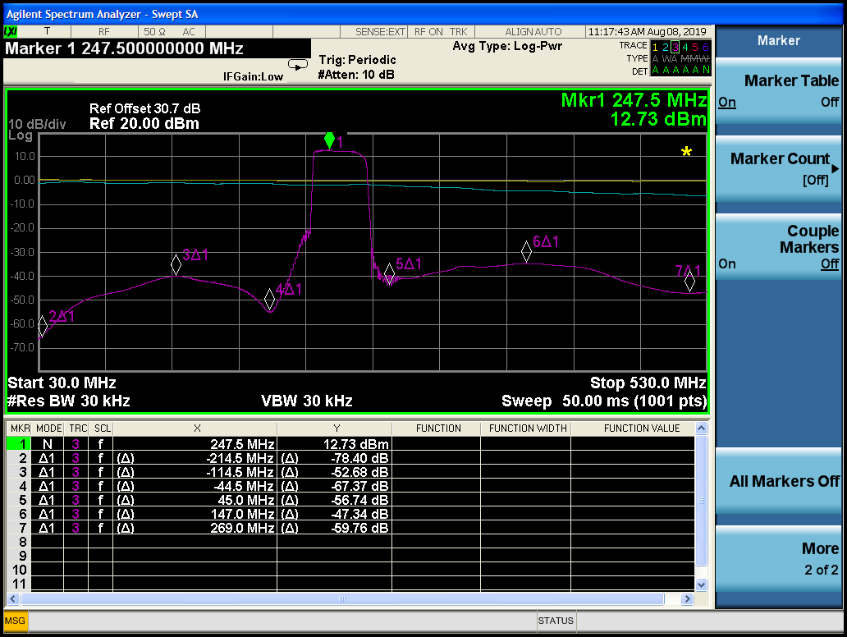
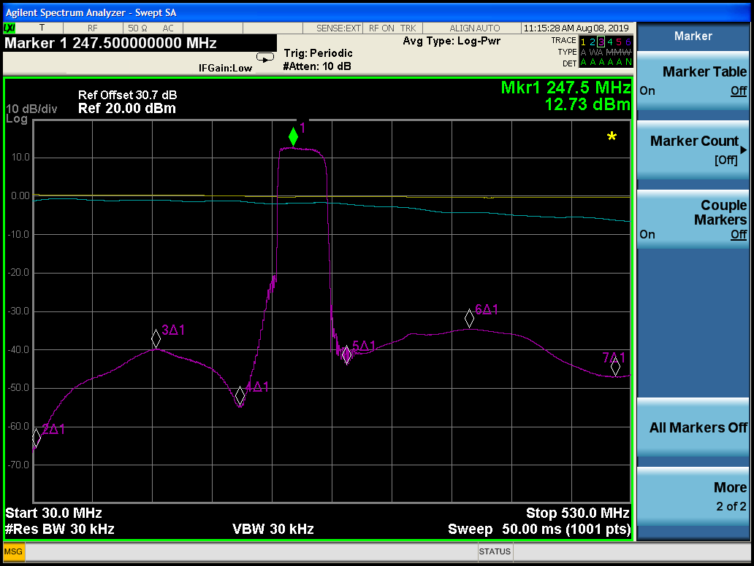
AR-50 - UNIT #1
DOC-00000198 RevA
8 August 2019

DOC-00000198 RevA August 2019
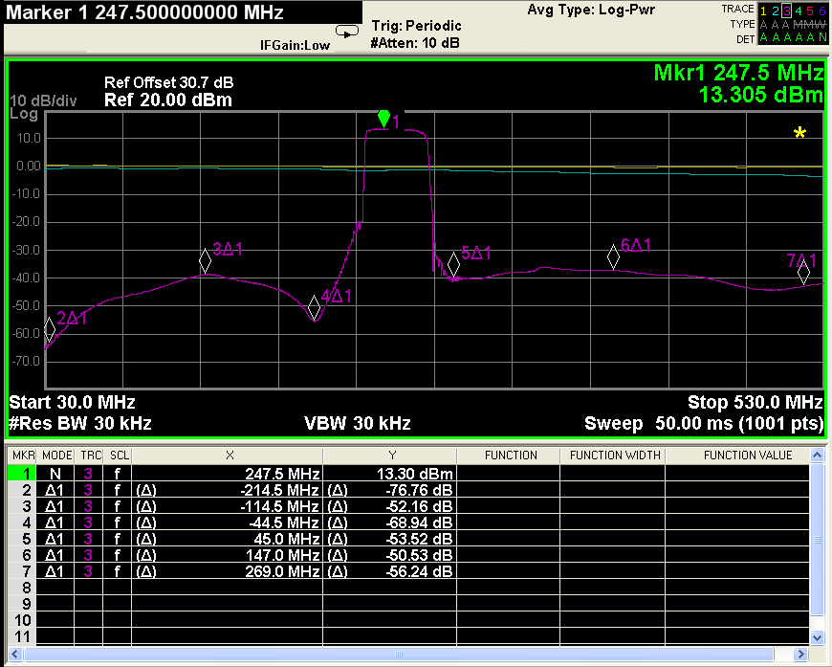
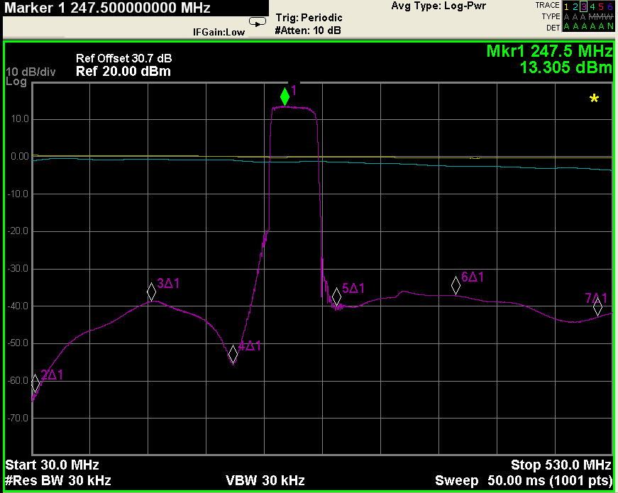
AR-50 - UNIT #2

DOC-00000198 RevA
8 August 2019
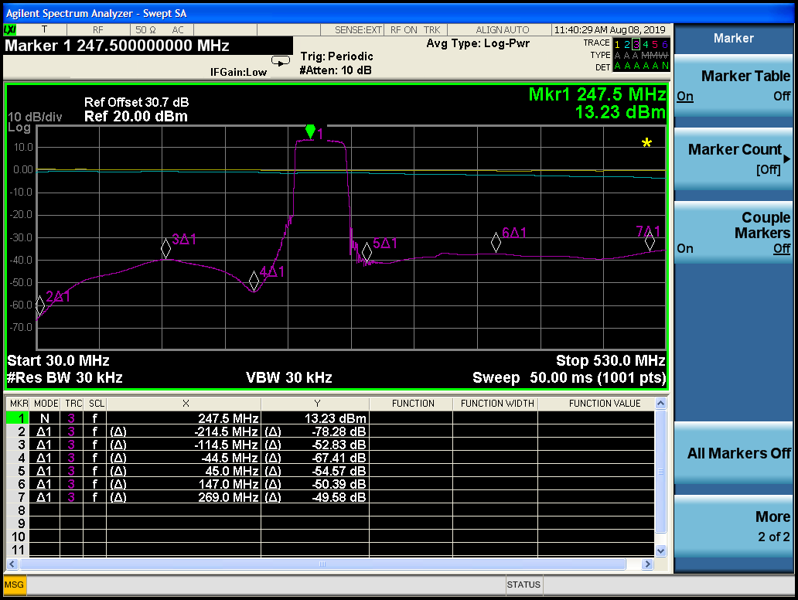
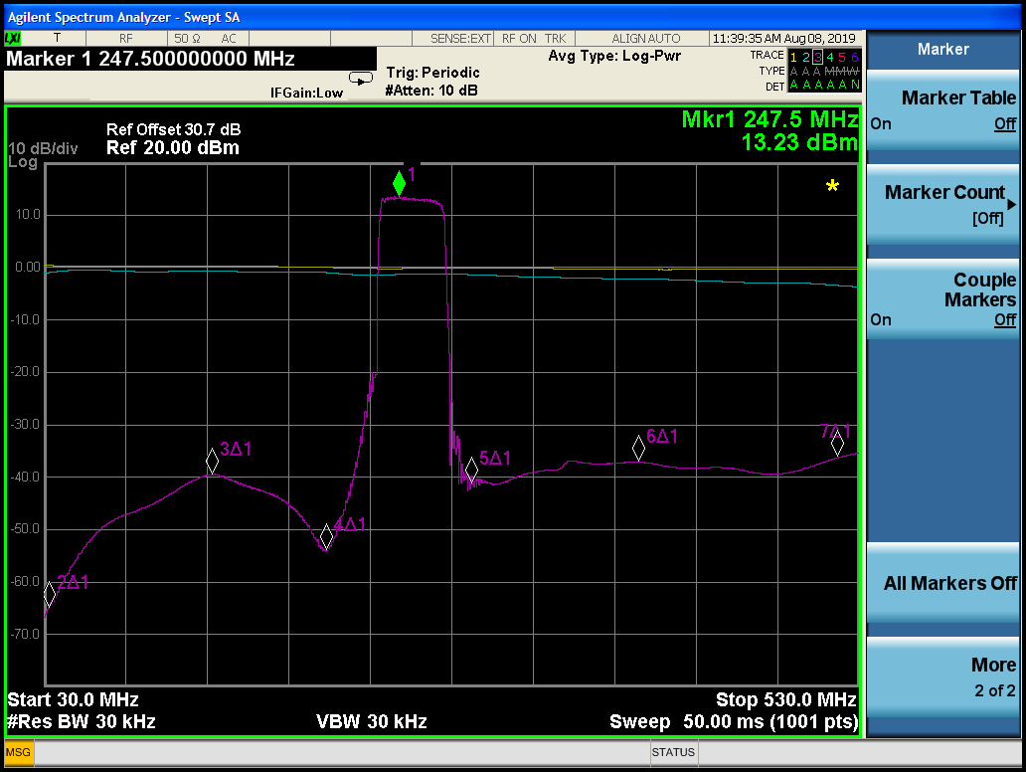
AR-50 - UNIT #3
DOC-00000198 RevA
8 August 2019

