AR-5000 Series

APPLIcation Note

Product Overview

Introduction

This application note describes three power control features available on AR-5000 Series amplifiers: GC (Gain Control), MLC (Maximum Level Control) and ALC (Automatic Level Control). Each of the three power control features, although related, are independent of one another and each serve a unique function.
Controlling the Gain, Output Power and Linearity Performance of a Power Amplifier enables the operator to maximize the performance of the system. Maintaining the proper power levels with the best Gain gives the system the best link distances while minimizing distortion and protecting subsequent RF equipment. The AR-5000 gives the operator the ability to fully manage Its performance thru a flexible interface to set up GC, MLC, and ALC.

For any other amplifier needs, AR Modular RF offers a wide variety of amplifier solutions including modules, rack mount and booster systems ranging from 80 kHz to 3000 MHz over a wide range of output powers.

AR-5000 Series highlights include:
- Rapid Prototyping
AR Modular RF understands the critical role a power amplifier plays in an RF system. With that in mind, the AR-5000 Series architecture is designed to support rapid prototyping with a quick turn on delivery for initial units perfect for the proof-of-concept stage of development. Depending on the application, a functional prototype can be available in as few as four (4) weeks following product definition.

- Early System Integration
The AR-5000 Series supports a robust, user-friendly, Ethernet-based remote-control interface with a fully defined API. All amplifier functions can be controlled either manually through front panel touch screen operation or remotely via Ethernet. A rapid functional prototype combined with a well-defined API enables system integrators to develop software and controls to vet performance and address system-level integration challenges faster and sooner.

- Cost Effective Solution
Tailored to your specific application, AR-5000 Series amplifiers are a cost-effective solution offering everything you need, but only what you need. Avoid purchasing a more expensive, laboratory grade, off-the-shelf amplifier that is overkill for your application – instead, get a design custom tailored to suit your systems needs.
Key Features:  - Touch Screen Control Interface  - Ethernet Remote Control  - Lightweight 19”, 2U/3U Chassis  - Rack Mount Enclosure  - AC Powered, Single Phase  - RF Gain / Input Attenuation Control  - Maximum Level Control  - Automatic Level Control  - Input Overdrive Protection  - Output VSWR Protection  - Over Temperature Protection  - Unconditionally Stable  - Forward & Reflected Power Monitoring  - Blanking | 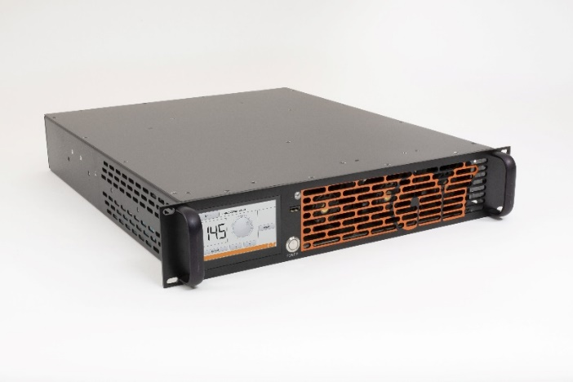

Released Products
As of Q2 2020, there are three amplifiers in the AR-5000 Series:
- AR-5010 [30 to 88 MHz, 500-Watt average linear amplifier]
The AR-5010 is the modern replacement for the legacy amplifier model KAA4040M11. In additional to offering both local touch screen and remote Ethernet control, the AR-5010 provides the same power and performance as the KAA4040M11 at one-third of both the size and weight. The AR-5010 is deployed in a SINCGARS base station application. The amplifier simultaneously supports 24 frequency-hopping SINCGARS carriers, each at about 1-Watt output. In this application, each of the 24 channels are constantly hopping throughout the 30 to 88 MHz band. Although the customer’s application had a relatively low average power (that is, ~25 Watts versus 500 Watts CW of available power), the use-case demanded clean, linear performance to meet stringent harmonic and intermodulation requirements for their multi-carrier system with an un-filtered amplifier that supported SINCGARS frequency-hopping.

- AR-5030C2 [700 to 960 MHz, 80-Watt average linear amplifier for Shipboard Applications]
The AR-5030C2 is not a replacement of a specific legacy amplifier model – rather, with respect to RF performance, it is a largely custom design based on the standard AR-5000 Series architecture. The model is intended for deployment in a Navy ship-board application. For the AR-5030C2 design the customer requested custom ALC (Automatic Level Control) performance. ALC is designed with system integrators in mind – it allows users to set the desired output power of the amplifier, independent of input power, while maintaining signal integrity. For more details on ALC see the application note for MLC, ALC and GC (available upon request from AR Modular RF Sales).

- AR-5030 [700 to 960 MHz, 80-Watt average linear amplifier]
The AR-5030 is not a replacement of a specific legacy amplifier model – rather, with respect to RF performance, it is a largely custom design based on the standard AR-5000 Series architecture. The model lends itself well for the ISM band (902 MHz – 928 MHz) in long tunnels, security systems, railways, DoT industry and base station applications needing longer range. ALC is designed with system integrators in mind – it allows users to set the desired output power of the amplifier, independent of input power, while maintaining signal integrity. For more details on ALC see the application note for MLC, ALC and GC (available upon request from AR Modular RF Sales).

